241801053-J B Dhejasvi
EX-03 WTMA

HelloWorldServlet.java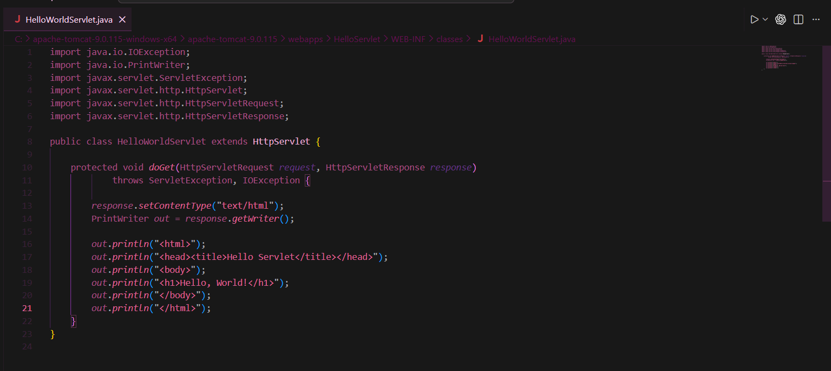
web.xml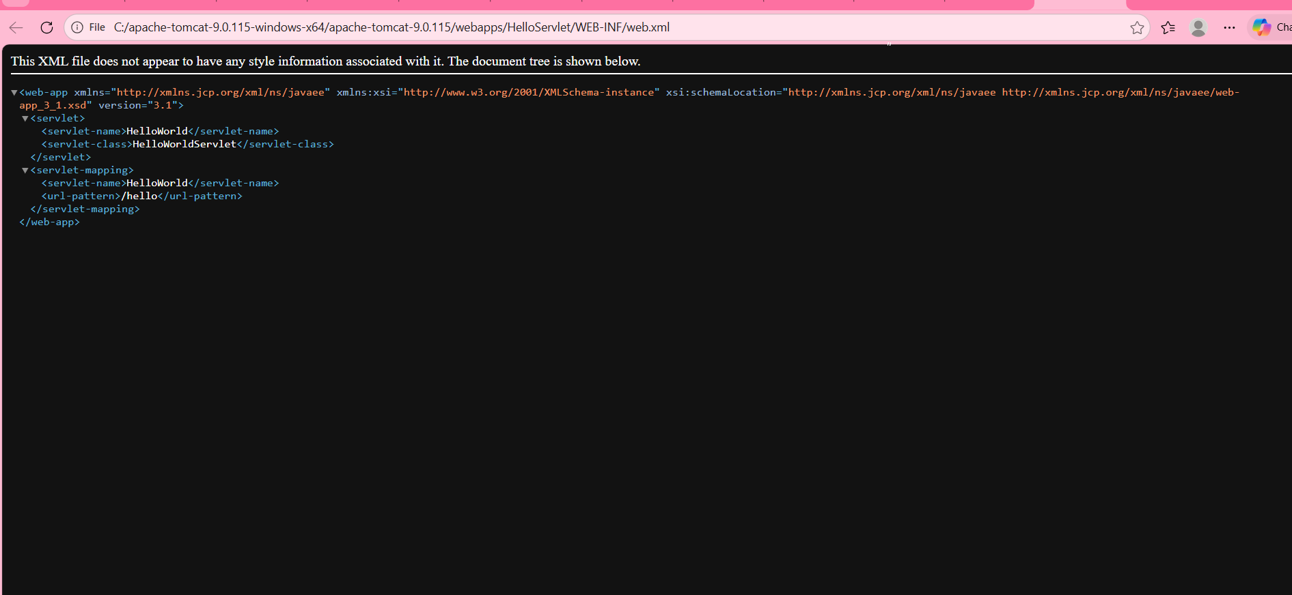

OUTPUT (along with tomcat running):